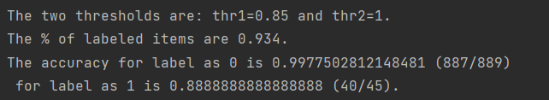

Th1 = 0.85, th2=1

Label 0 - incorrect



Label 1 - incorrect:

